# **AI-Powered Adaptive Quiz Game:**

# “A Personalized Learning Platform Using Generative AI and Machine Learning"

# **1. Introduction**

### **1.1 Problem Statement**

Traditional e-learning platforms and classroom environments often adopt a **static, one-size-fits-all** approach to learning. These systems typically deliver pre-designed content with fixed difficulty levels, regardless of the learner's pace, knowledge gaps, or progression. As a result, learners may encounter:

* Repetition of concepts they already understand.
* Exposure to content that is either too easy (causing boredom) or too difficult (causing frustration).
* Lack of personalized feedback and adaptation, resulting in reduced engagement and poor retention.

These shortcomings hinder effective knowledge transfer and fail to accommodate diverse learning profiles. To overcome these limitations, there is a strong need for **adaptive learning systems** that can:

* Dynamically **tailor quizzes and content** based on a learner’s performance in real-time.
* Provide **immediate feedback**, intelligent hints, and guidance to reinforce learning.
* Predict optimal content difficulty and track progression across various topics.

Our proposed solution addresses this challenge by developing an **AI-driven adaptive quiz system** that integrates **Generative AI**, **machine learning models**, and **intuitive user interfaces** to offer a personalized, performance-oriented learning experience.

### **1.2 Objective**

The primary objective of the **AI-Powered Adaptive Quiz Game** is to build a scalable, modular, and intelligent platform that enhances student engagement and learning efficiency through adaptively generated quizzes and insights. This project aims to bridge the gap between standardized assessments and personalized learning journeys. The specific goals include:

* **Automated Quiz Generation**: Leveraging a fine-tuned **T5 transformer model** to dynamically generate domain-specific questions based on contextual passages and learner-selected topics.
* **Adaptive Difficulty Prediction**: Utilizing a trained **XGBoost classifier** to adjust quiz difficulty levels (easy, medium, hard) in real time based on a user’s accuracy, average response time, and retry behavior.
* **Gamified Feedback Mechanism**: Delivering immediate results with motivational messages, AI-assessed difficulty insights, and streak tracking to enhance user motivation.
* **Performance Monitoring**: Providing users with detailed dashboards that visualize score progression, topic-wise performance, and improvement statistics to guide future learning.
* **Personalized Recommendations**: Integrating **AI-based learning suggestions**, including curated YouTube tutorials and course links, tailored to each learner’s subject proficiency and quiz history.
* **End-to-End Integration**: Combining modern frontend frameworks (Next.js + Tailwind CSS) with a robust backend (Node.js + Flask + MongoDB) to create a seamless and interactive learning platform.

By aligning with the objectives of adaptive education and personalized learning, this project sets the foundation for an intelligent tutor system that continuously evolves with the learner and supports lifelong knowledge development.

## **2. Literature Review**

Over the past few years, **Generative AI** has become a game-changer in the field of education. It’s now possible to create personalized learning paths and generate custom quizzes, lessons, or even full interactive experiences — all powered by AI. This shift is making learning more dynamic, engaging, and suited to the unique needs of each student.

One influential approach in this area is the **GAIDE framework (Generative AI for Dynamic Educational Content)**, introduced by **Dickey and Bejarano**. Their model focuses on using AI to automatically generate educational material like quizzes and puzzles. The goal is to reduce the manual workload for educators while keeping the content flexible and personalized for students. So instead of designing static tests or assignments, teachers can rely on AI to adapt the content based on what students need — letting educators focus more on teaching rather than content creation [1].

Building on this, **Łodzikowski, Foltz, and Behrens** highlighted how **adaptive learning** can be enhanced by AI. Their research explains how AI systems can assess a student’s performance and adjust the difficulty of content accordingly. For example, if a student is consistently getting answers right, the system will gradually make the questions harder. But if they’re struggling, it’ll ease off and offer simpler questions to build confidence. It’s a smart way to keep students challenged — but not overwhelmed. That said, they also caution about the **ethical side** of things — especially ensuring that AI doesn’t introduce bias or inaccuracies in the learning content [2].

Another interesting study by **Maity and Deroy** focused on using **generative AI within Intelligent Tutoring Systems (ITS)**. These systems don’t just serve fixed questions — they create new ones on the fly based on the learner’s performance. This means the learning journey can evolve continuously, offering **real-time feedback** and testing exactly what the student needs at that moment. It’s like having a personal tutor who adjusts lessons as you learn — all powered by AI [3].

In addition to traditional quizzes and assessments, researchers are also exploring more **creative ways to teach**. One such approach is **interactive storytelling**, where students learn through dynamic, AI-generated narratives. Platforms like **AI Dungeon** have shown how students can engage with content by making decisions that influence the story. Imagine learning history by stepping into a role in a simulated historical event — it makes abstract topics much more relatable and exciting [4].

Finally, there’s been a rise in **AI-powered chatbots** like **ChatGPT** being used in classrooms. These tools allow students to ask questions and get detailed explanations instantly. While it’s incredibly helpful, the key is to use it responsibly — as a support system, not a replacement for critical thinking. Educators must ensure these tools encourage exploration and reasoning, rather than just spoon-feeding answers [5].

To sum up , the body of research clearly shows that **Generative AI is transforming education**. Whether it’s through real-time adaptive quizzes, personalized learning paths, or immersive storytelling, AI is making education more tailored and impactful. However, it’s equally important to address challenges around accuracy, bias, and ethical use — so that these technologies genuinely support every learner’s growth.

### **3. Technologies Employed**

#### **Backend:**

1. **Node.js & Express.js**
   * **Node.js** is used for the backend of the AI-Powered Adaptive Quiz Game. It is a server-side JavaScript runtime that enables the platform to handle high volumes of concurrent connections in real time. It’s known for its non-blocking, event-driven architecture, making it ideal for applications that require real-time processing, like live quizzes and feedback.
   * **Express.js** is used as the framework to build the API server. It is a minimalist web framework for Node.js that simplifies routing, middleware integration, and handling HTTP requests. Express helps manage user authentication, quiz submissions, and the interaction with AI models by handling incoming requests and responding with the appropriate data.
2. **Flask (Python)**
   * Flask serves as the backend framework for the AI-Powered Adaptive Quiz Game's machine learning models. It is lightweight and highly flexible for serving machine learning models. Flask is used to set up endpoints that provide model predictions, such as determining quiz difficulty or generating personalized quiz questions.
   * It is particularly useful for serving **XGBoost** and other models related to quiz difficulty prediction, where the model’s output is returned to the frontend in real-time.
3. **XGBoost**
   * **XGBoost** is a powerful and efficient machine learning algorithm used to predict the quiz difficulty for a user. It analyzes data like the user's past performance, quiz attempts, time taken per question, and retries. This helps determine whether the next set of questions should be easier, harder, or of similar difficulty, ensuring a balanced learning experience.
   * **XGBoost** excels in predictive tasks, and its use here helps make the adaptive learning system intelligent by dynamically adjusting quiz difficulty based on student performance.
4. **Pickle (Python)**
   * **Pickle** is used for serializing the trained machine learning models (e.g., XGBoost model). It allows the models to be saved in a serialized format to the disk so that they can be reloaded without needing to retrain them every time the application starts. This leads to faster application startup and efficient model reuse.

#### **Frontend:**

1. **Next.js**
   * The frontend of the AI-Powered Adaptive Quiz Game is built using **Next.js**, a React-based framework. **Next.js** provides a full-stack solution, making it easy to build a fast, scalable, and SEO-optimized web application. Key features of **Next.js** like **server-side rendering (SSR)** and **static site generation (SSG)**ensure fast performance and smoother user interactions. It is used for routing, page management, quiz display, and the overall user interface.
2. **React.js**
   * **React.js** is used for building dynamic, reusable, and interactive UI components. In the quiz game, **React**powers the quiz interface, handling dynamic updates such as displaying questions, providing multiple-choice answers, handling user inputs, updating scores, and providing real-time feedback.
3. **Tailwind CSS**
   * **Tailwind CSS** is a utility-first CSS framework used to style the frontend. It allows rapid and flexible UI design with predefined utility classes for styling components. **Tailwind** makes the development process faster by reducing the need for writing custom CSS and provides a clean, responsive, and consistent UI for the quiz game.

#### **Machine Learning:**

1. **T5 (Generative AI for Quiz Generation)**
   * **T5 (Text-to-Text Transfer Transformer)** is used for dynamically generating quiz questions based on given content. **T5** takes a text passage or user-provided topic and transforms it into multiple-choice questions. This approach ensures that the quiz content remains fresh and adapts to the learner’s current topic of interest, creating an engaging and personalized learning experience.
   * **T5** also adjusts the difficulty level of the questions based on previous responses, creating an intelligent feedback loop that personalizes the content for each user.
2. **XGBoost**
   * **XGBoost** plays a crucial role in predicting the difficulty of upcoming questions based on the learner’s performance. It evaluates user performance metrics like accuracy, response time, and retries. Using these features, **XGBoost** adjusts the difficulty of the next questions, ensuring that the quiz is neither too easy nor too hard, optimizing the learning curve for the user.
3. **SVD (Singular Value Decomposition) for Personalized Recommendations**
   * **SVD (Singular Value Decomposition)** is used for **collaborative filtering** to recommend personalized quiz questions. By analyzing the patterns of previous users’ responses, **SVD** helps identify similarities in performance and suggests questions based on users' strengths and weaknesses. It helps to personalize the quiz experience by adapting the content to the learner's level of knowledge.

#### **Data Handling and Visualization:**

1. **NumPy & Pandas**
   * **NumPy** and **Pandas** are used for data processing and manipulation. **NumPy** is responsible for handling large arrays and performing mathematical computations, such as calculating averages and processing numerical data for machine learning. **Pandas** helps organize and clean the data, making it suitable for feeding into the models. It is also used for tasks like splitting data, filtering, and analyzing trends in user performance.
2. **Matplotlib & Seaborn**
   * **Matplotlib** and **Seaborn** are used for visualizing the user’s progress. For example, **Matplotlib** generates line graphs that track score progression, while **Seaborn** produces more complex statistical plots that help analyze correlations and distributions within the quiz data, providing insights into areas like quiz difficulty and student performance.
3. **Scikit-learn**
   * **Scikit-learn** is a machine learning library that provides tools for preprocessing data, splitting datasets, and evaluating model performance. It is used to scale and normalize the quiz data for machine learning, split the data into training and testing sets, and evaluate model accuracy.

**4. System Architecture**

The architecture of the **AI-Powered Adaptive Quiz Game** system follows a multi-layered, modular approach. It integrates the frontend, backend, machine learning models, and database to provide a seamless, personalized learning experience.

#### **Frontend (React.js + Next.js)**

The frontend is built using **React.js** and **Next.js**, which together offer a fast, responsive, and scalable solution. It’s designed to handle dynamic quiz generation, real-time interactions, and personalized user feedback.

* **User Input Handling:** Collects data such as User ID, Question ID, Previous Answers, and Time Taken.
* **Quiz Interface:** Displays questions, multiple-choice answers, and real-time feedback on quiz performance.
* **Results Display:** After completing the quiz, users can see their performance, AI-predicted difficulty, and personalized recommendations.

#### **Backend (Node.js + FastAPI)**

The backend is responsible for managing user sessions, handling API requests, and communicating with machine learning models to provide predictions and recommendations in real-time.

* **User Interaction Handling:** The frontend sends data (answers, time, etc.) to the backend, which processes it and interacts with machine learning models to predict the difficulty level and generate recommendations.
* **Model Integration:** The backend calls **XGBoost** and **T5** for prediction and quiz generation.
* **Real-time Feedback:** The backend sends real-time responses, quiz difficulty, and recommendations back to the frontend.

#### **Machine Learning Models:**

1. **T5 (Generative AI for Quiz Generation)** - Generates dynamic quiz questions based on context or selected topics.
2. **XGBoost (Performance Prediction)** - Predicts the optimal difficulty for upcoming quizzes based on user performance data.
3. **SVD (Personalized Question Recommendations)** - Recommends questions based on past performance and similarity to other users.

#### **Database (MongoDB)**

**MongoDB** is used for storing and managing user data, including quiz results, past performance, and user interactions. This allows the system to track progress over time and adapt quizzes to the learner’s needs.

### **System Architecture Diagram**

Here is the system architecture diagram that explains the flow of information in the **AI-Powered Adaptive Quiz Game**:

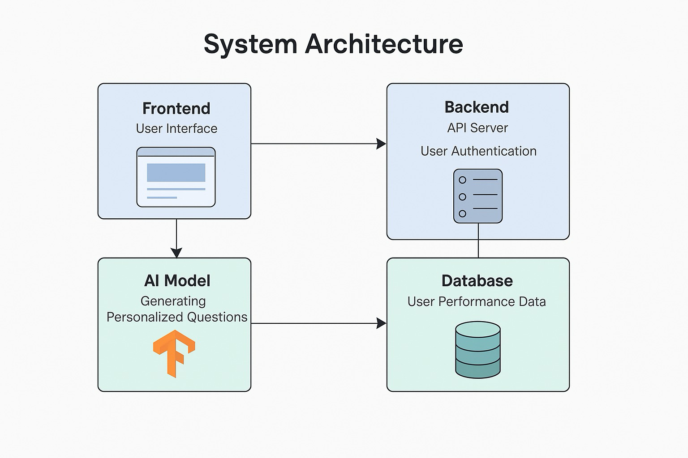

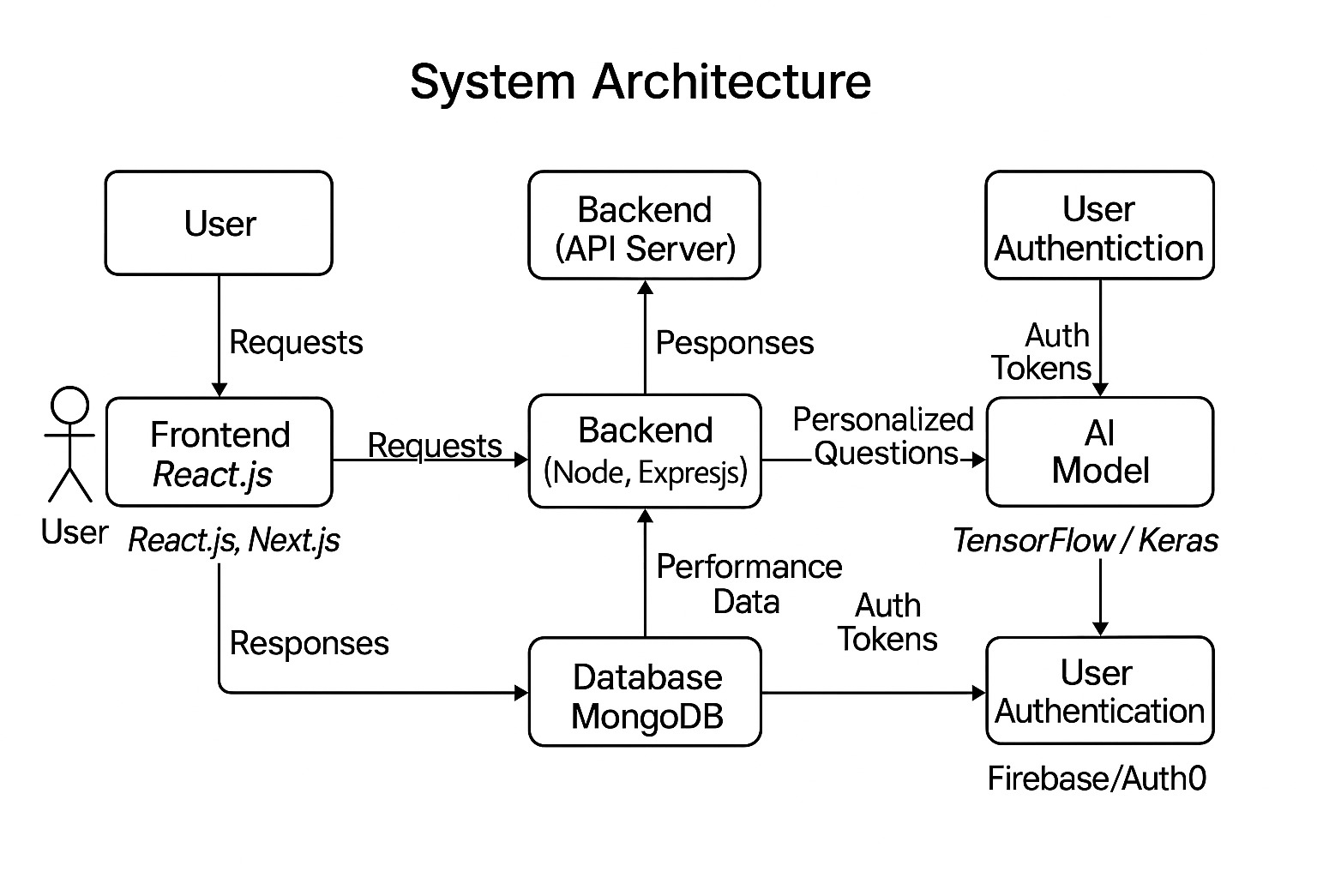

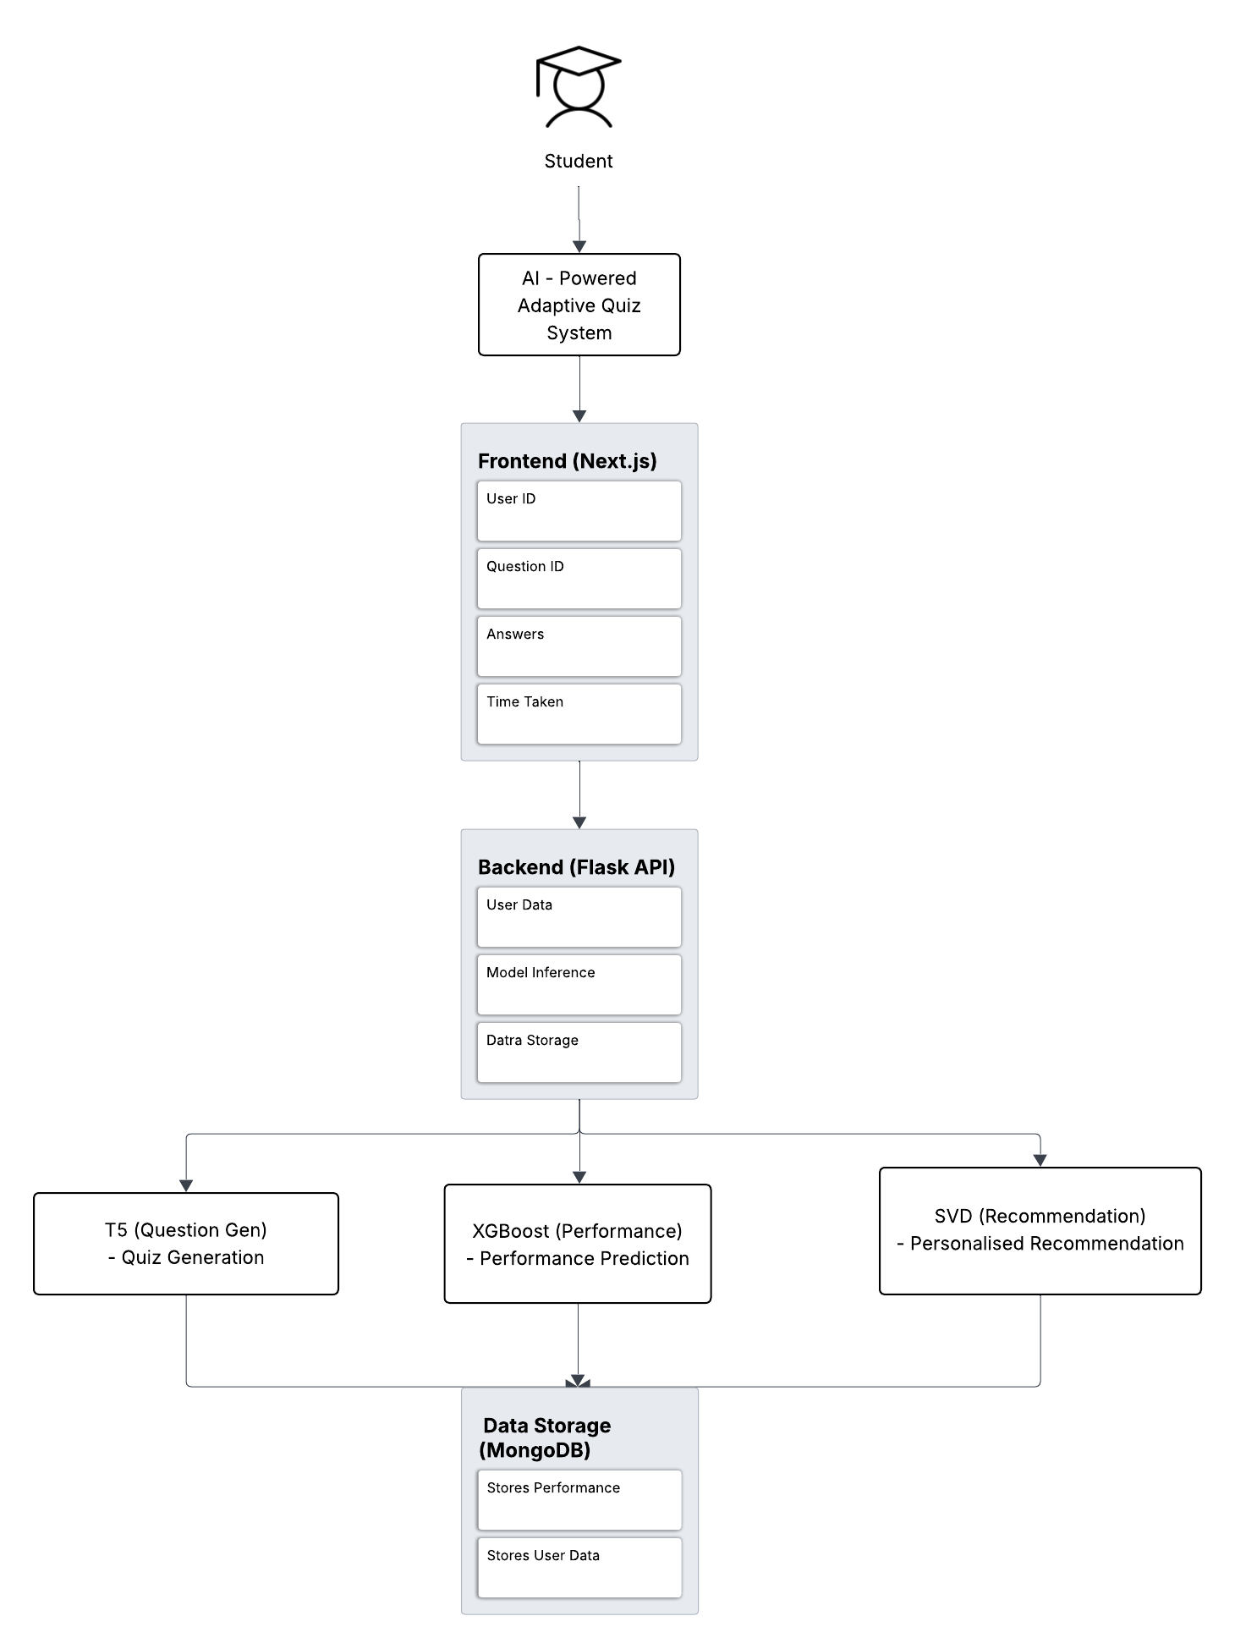

**Data Flow Diagram**

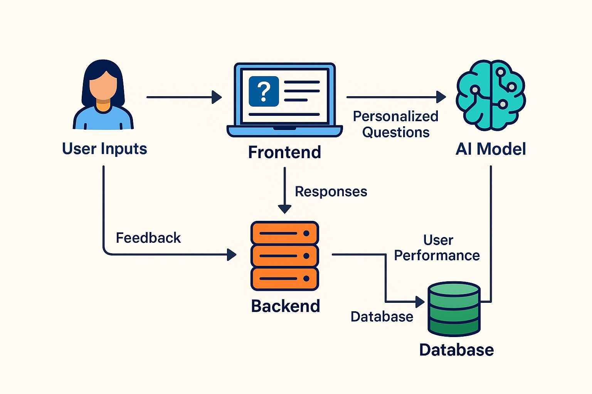

**Component Interaction Diagram**

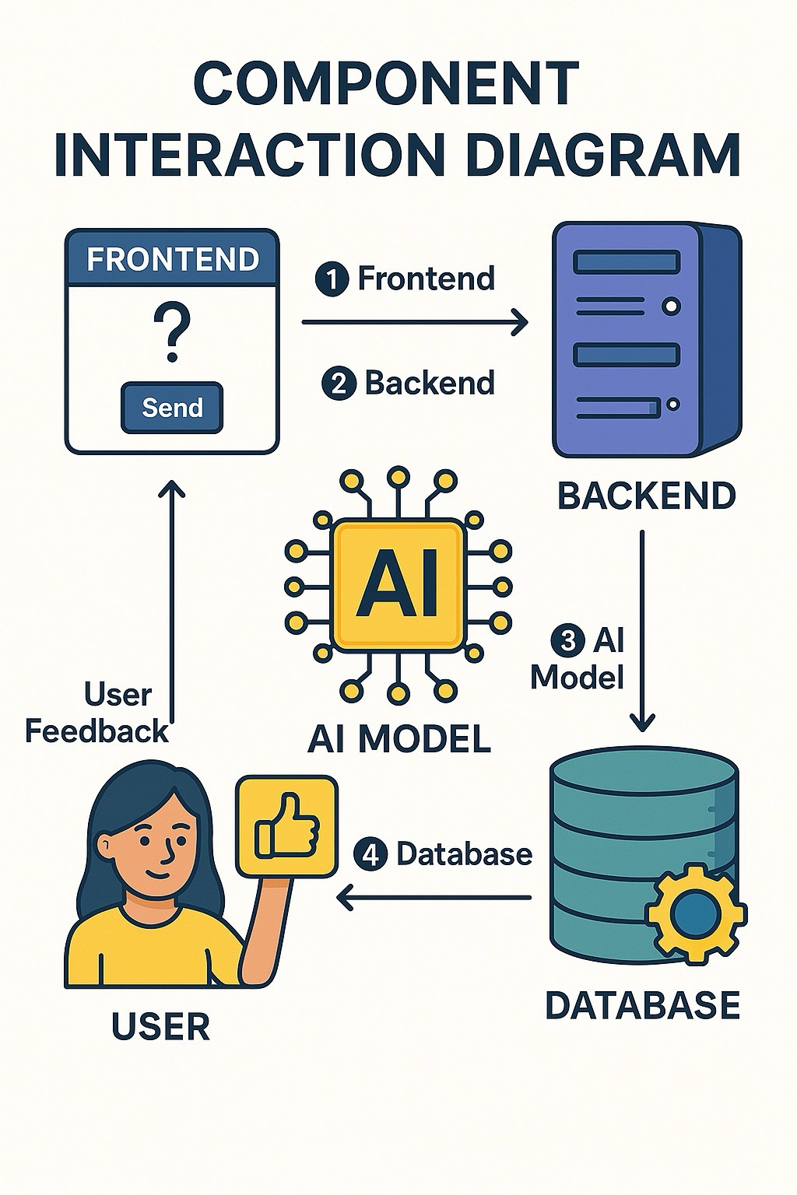

**Quiz Interface Preview**

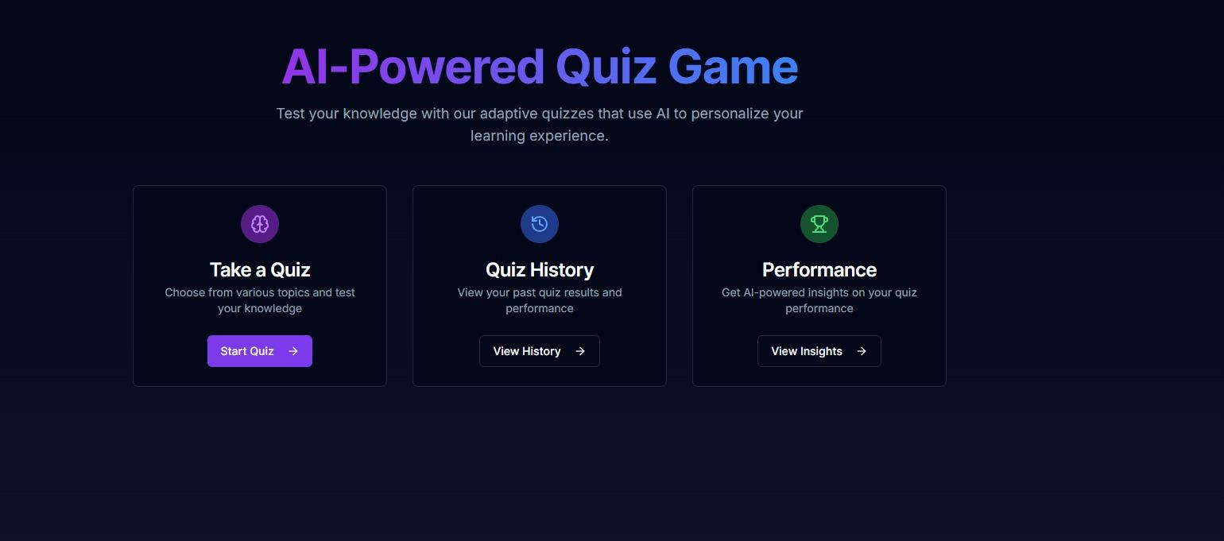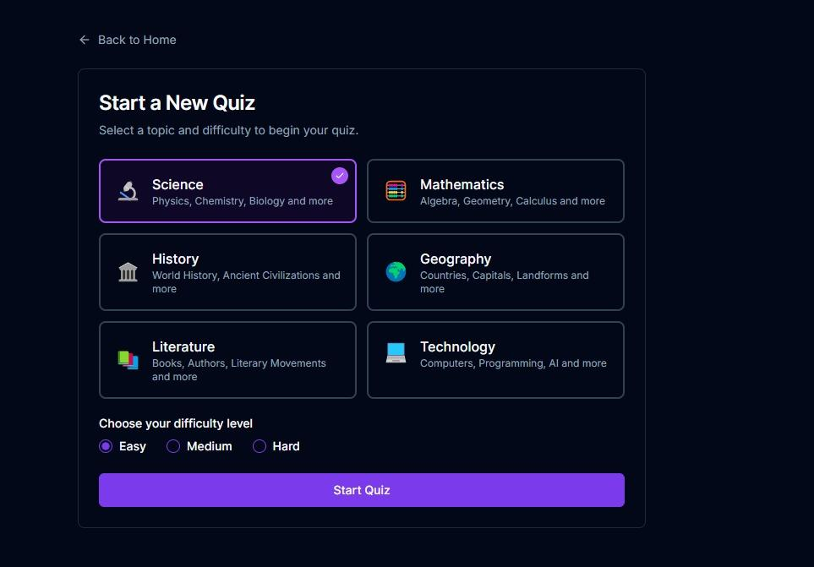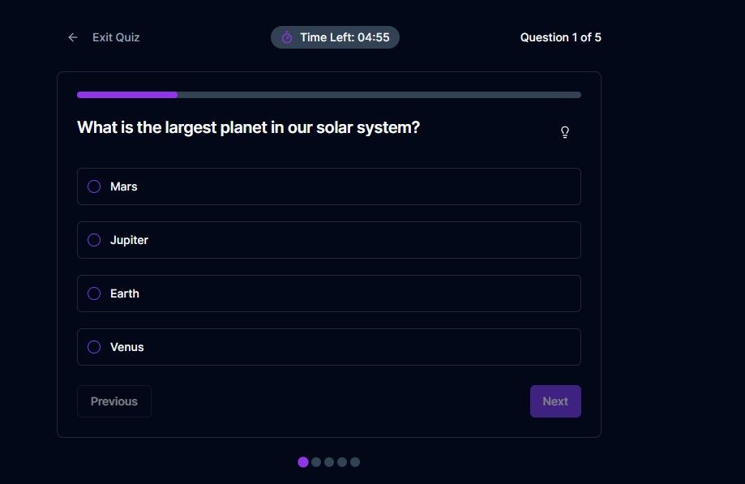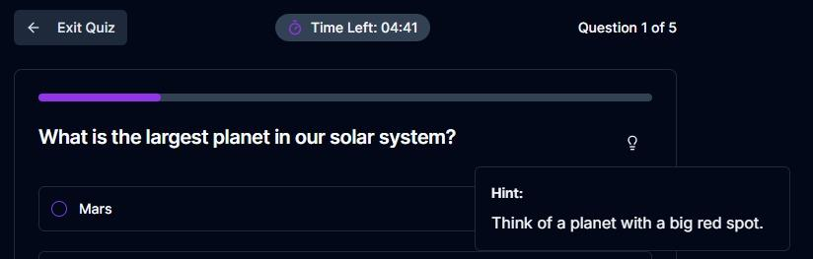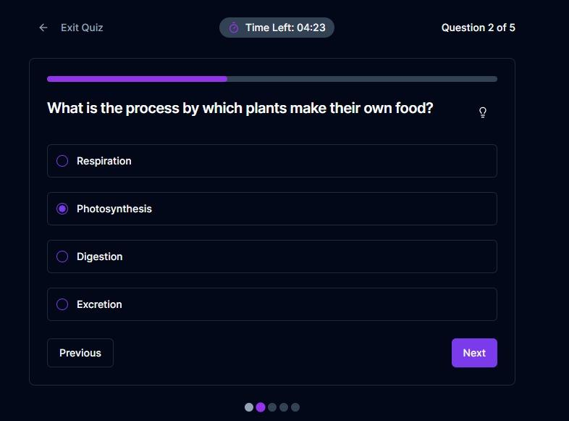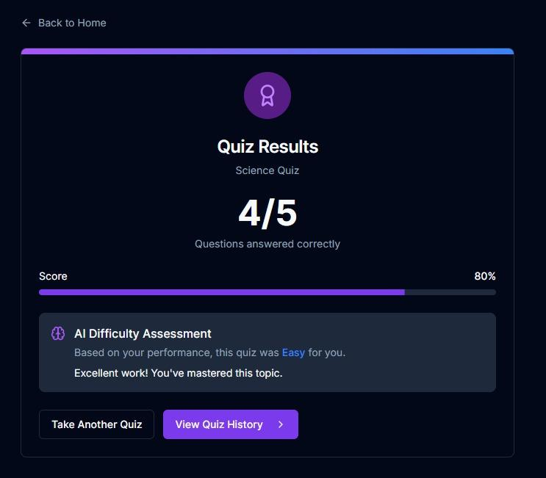

**Past Quiz Results Overview**

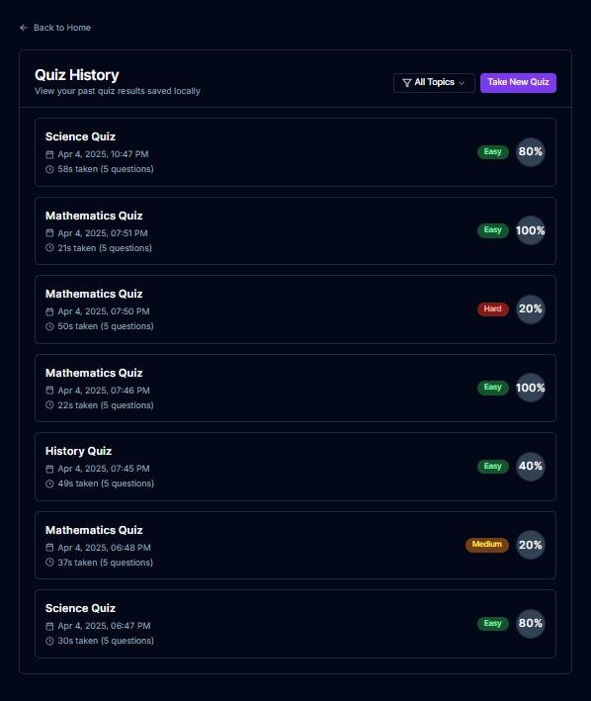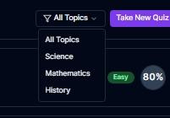

**Performance Metrics from Completed Quizzes**

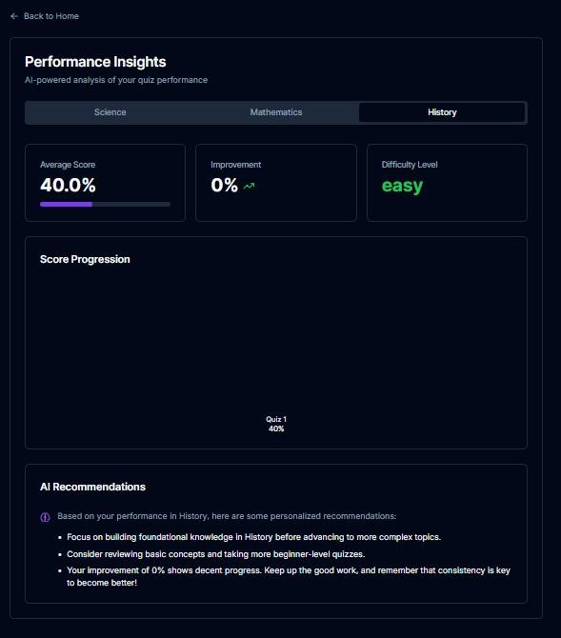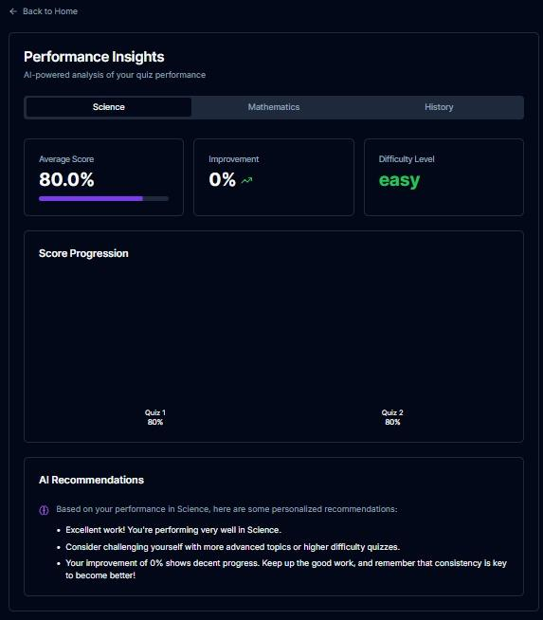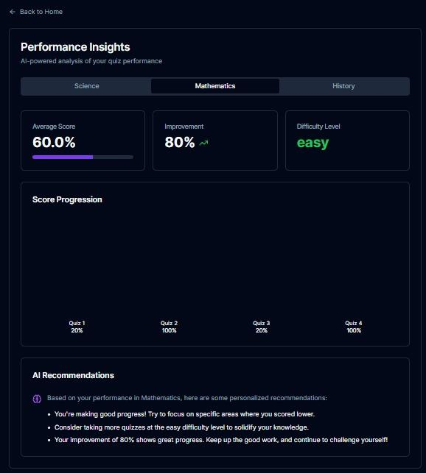

### **5. Dataset & Data Preprocessing**

In this project, we used multiple datasets to train and evaluate our machine learning models for quiz generation, difficulty prediction, and personalized recommendations. The datasets are crucial to the performance of the models, as they provide real-world data on student behavior, quiz performance, and learning patterns.

#### **Datasets Used:**

1. **SQuAD (Stanford Question Answering Dataset)**: This dataset is used for general knowledge and science-related questions. It consists of question-answer pairs based on passages from Wikipedia articles.
2. **MathQA**: This dataset focuses on mathematical questions, providing a rich source of problems ranging from basic arithmetic to complex problem-solving.
3. **AI2 Science Questions (AI2 ARC)**: This dataset contains a range of science-related questions, including physics, chemistry, and biology topics.

#### **Data Preprocessing:**

Before using the data for model training, several preprocessing steps were performed:

* **Tokenization**: We tokenized the question-answer pairs from the datasets, breaking them into smaller pieces (tokens) that can be processed by the models. This ensures that both the input (context) and output (questions) are in a format that the models can understand.
* **Normalization**: We normalized numerical values in the dataset (such as the time taken to answer questions) to ensure they were in a consistent scale, improving the model’s ability to process them effectively.
* **Data Splitting**: We split the datasets into training, validation, and test sets, ensuring that the models could learn from one subset while being evaluated on a separate, unseen subset of data.
* **Handling Missing Data**: Missing data in the datasets (e.g., incomplete answers) were either removed or imputed using statistical techniques to ensure the models could handle all data points effectively.

This data preprocessing pipeline enabled the machine learning models to learn from clean, structured data and improved their ability to generate adaptive quizzes and make performance predictions.

### **6. Models Used and Executed**

Several machine learning models were used in this project to deliver the personalized, dynamic learning experience:

1. **T5 (Text-to-Text Transfer Transformer)**:
   * **Role**: Used for dynamically generating quiz questions from input text (e.g., a passage or topic).
   * **Execution**: We fine-tuned the T5 model using the dataset of quiz questions. By providing it with contextual information (e.g., a passage of text or a specific topic), the model could generate relevant multiple-choice questions in real-time. It adapted the question complexity based on the student’s previous performance.
2. **XGBoost (Extreme Gradient Boosting)**:
   * **Role**: Used for predicting quiz difficulty based on user performance.
   * **Execution**: The XGBoost model was trained to predict the likelihood of a user answering the next question correctly. We used user data such as **number of correct answers**, **time taken per question**, and **retries** as features to predict the optimal difficulty level for the next set of questions. This model was integral in ensuring that the quiz stayed challenging without overwhelming the student.
3. **SVD (Singular Value Decomposition)**:
   * **Role**: Used for providing personalized question recommendations.
   * **Execution**: We employed SVD to analyze user performance data and suggest new questions based on past behavior. SVD helps identify similarities between the user’s responses and those of others with similar performance. This model was key in ensuring that the system could recommend questions that were both relevant and appropriately challenging for each student.

These models were integrated into the backend of the system, where they processed user inputs in real-time, provided personalized recommendations, and adapted the quiz content to enhance learning outcomes.

### **11. Results and Evaluation**

The performance of the **AI-Powered Adaptive Quiz Game** was evaluated using several metrics and methods to assess the effectiveness of quiz generation, difficulty prediction, and personalized recommendations.

#### **Results:**

* **Quiz Generation**: The T5 model was able to generate meaningful and relevant quiz questions with high accuracy, based on the context provided. The generated questions matched the topics selected by users, and the difficulty of questions was dynamically adjusted based on their past performance.
* **Difficulty Prediction**: The XGBoost model successfully predicted quiz difficulty levels based on user performance data. The model was able to accurately adjust difficulty in real-time, keeping the quizzes appropriately challenging and engaging.
* **Personalized Recommendations**: The SVD model recommended questions that were personalized based on the user’s historical quiz performance. Users reported that the recommendations helped them focus on areas where they needed the most improvement.

#### **Evaluation Metrics:**

* **Accuracy**: The models achieved a high accuracy rate in predicting user performance and generating relevant quiz content. We measured this by comparing predicted outcomes (e.g., quiz difficulty, next question's correctness) with actual user behavior.
* **F1 Score**: We used the F1 score to evaluate the precision and recall of the models, especially for the prediction tasks, to ensure a balanced performance in generating correct difficulty levels and appropriate questions.
* **User Feedback**: Students and educators provided feedback on the quality of the quiz questions and recommendations, reporting that the system helped tailor learning experiences more effectively than traditional static systems.

The evaluation results demonstrated that the system was successful in adapting quiz difficulty and providing personalized learning paths, enhancing user engagement and learning outcomes.

### **12. Conclusion**

The **AI-Powered Adaptive Quiz Game** successfully integrates **Generative AI** and **Machine Learning** techniques to provide personalized learning experiences. By leveraging **T5** for quiz generation, **XGBoost** for difficulty prediction, and **SVD** for personalized recommendations, the system ensures that quizzes are dynamically tailored to the learner’s needs.

The project demonstrated how **adaptive learning systems** can overcome the limitations of traditional educational models, such as one-size-fits-all quizzes. The system not only improves user engagement but also enhances the learning process by continuously adapting to each student’s progress. The **real-time feedback**, **personalized learning paths**, and **dynamic difficulty adjustments** help maintain a challenging but not overwhelming learning environment.

### **13. Future Work**

While the project has shown promising results, there are several areas for improvement and expansion:

1. **Enhanced Personalization**:
   * Future iterations could include more detailed models for **personalized feedback**, including tailored learning paths and progress tracking.
   * Integrating **natural language processing (NLP)** capabilities to allow students to ask questions or provide responses in natural language could further enhance the interactivity of the system.
2. **Gamification**:
   * Implementing **gamified elements** such as levels, achievements, and leaderboards could increase student motivation and engagement.
   * Adding features like **badges** or **virtual rewards** for completing quizzes or achieving high scores could further incentivize learning.
3. **Expand Subject Coverage**:
   * The system could be expanded to support additional subjects beyond math and science, including humanities, language learning, and history.
   * Including more domain-specific datasets and enhancing the question generation models for these subjects would improve the platform’s versatility.
4. **Scalability**:
   * Scaling the system to handle a large number of concurrent users, integrating cloud-based solutions, and optimizing the backend infrastructure for **distributed learning environments** would allow the system to support more learners globally.
5. **AI Model Improvement**:
   * The current models can be further fine-tuned and optimized with **more data** and **additional features** such as user preferences, study habits, and time spent on specific topics to make the quiz more accurate and personalized.

By incorporating these future improvements, the AI-Powered Adaptive Quiz Game can become a more powerful tool for personalized education, capable of adapting to the diverse learning needs of students worldwide.

### **14. References**

1. Dickey, M., & Bejarano, J. (2023). *GAIDE: A Framework for Using Generative AI to Assist in Course Content Development*. Retrieved from [arxiv.org](https://arxiv.org/abs/2308.12276).
2. Łodzikowski, A., Foltz, P., & Behrens, L. (2024). *Generative AI and Its Educational Implications*. Retrieved from [arxiv.org](https://arxiv.org/abs/2401.08659).
3. Maity, S., & Deroy, P. (2024). *Generative AI and Its Impact on Personalized Intelligent Tutoring Systems*. Retrieved from [arxiv.org](https://arxiv.org/abs/2410.10650).
4. Narrative-Based Learning (2023). *Narrative-Based Learning in Virtual Environments*. Retrieved from [en.wikipedia.org](https://en.wikipedia.org/wiki/Narrative-based_learning).
5. AI Dungeon (2023). *AI-Generated Interactive Storytelling*. Retrieved from [en.wikipedia.org](https://en.wikipedia.org/wiki/AI_Dungeon).
6. Generative AI (2023). *Generative AI: Implications and Applications for Education*. Retrieved from [arxiv.org](https://arxiv.org/abs/2305.07605).
7. ChatGPT in Education (2023). *ChatGPT in Education: Enhancing Learning Experiences*. Retrieved from [en.wikipedia.org](https://en.wikipedia.org/wiki/ChatGPT_in_education).